Ideation Phase

Brainstorm & Idea Prioritization Template

|  |  |
| --- | --- |
| Date | APRIL2023 |
| Team ID | NM2023TMID15986 |
| Project Name | A Review Of Liver Patient Analysis Methods Using  Machine Learning. |
| Maximum marks | 5 Marks |

**Brainstorm And Idea Prioritization:**

Under this activity our team members have gather and discuss various ideas to solve our project problem each member contributed six to ten ideas.

After gathering all the ideas we have assessed the impact and feasibility of each point.

Finally, we have assign the priority for each point based on these impact values.

**Step:1** – **Team Gathering, Collaboration and Select The Problem Statement**

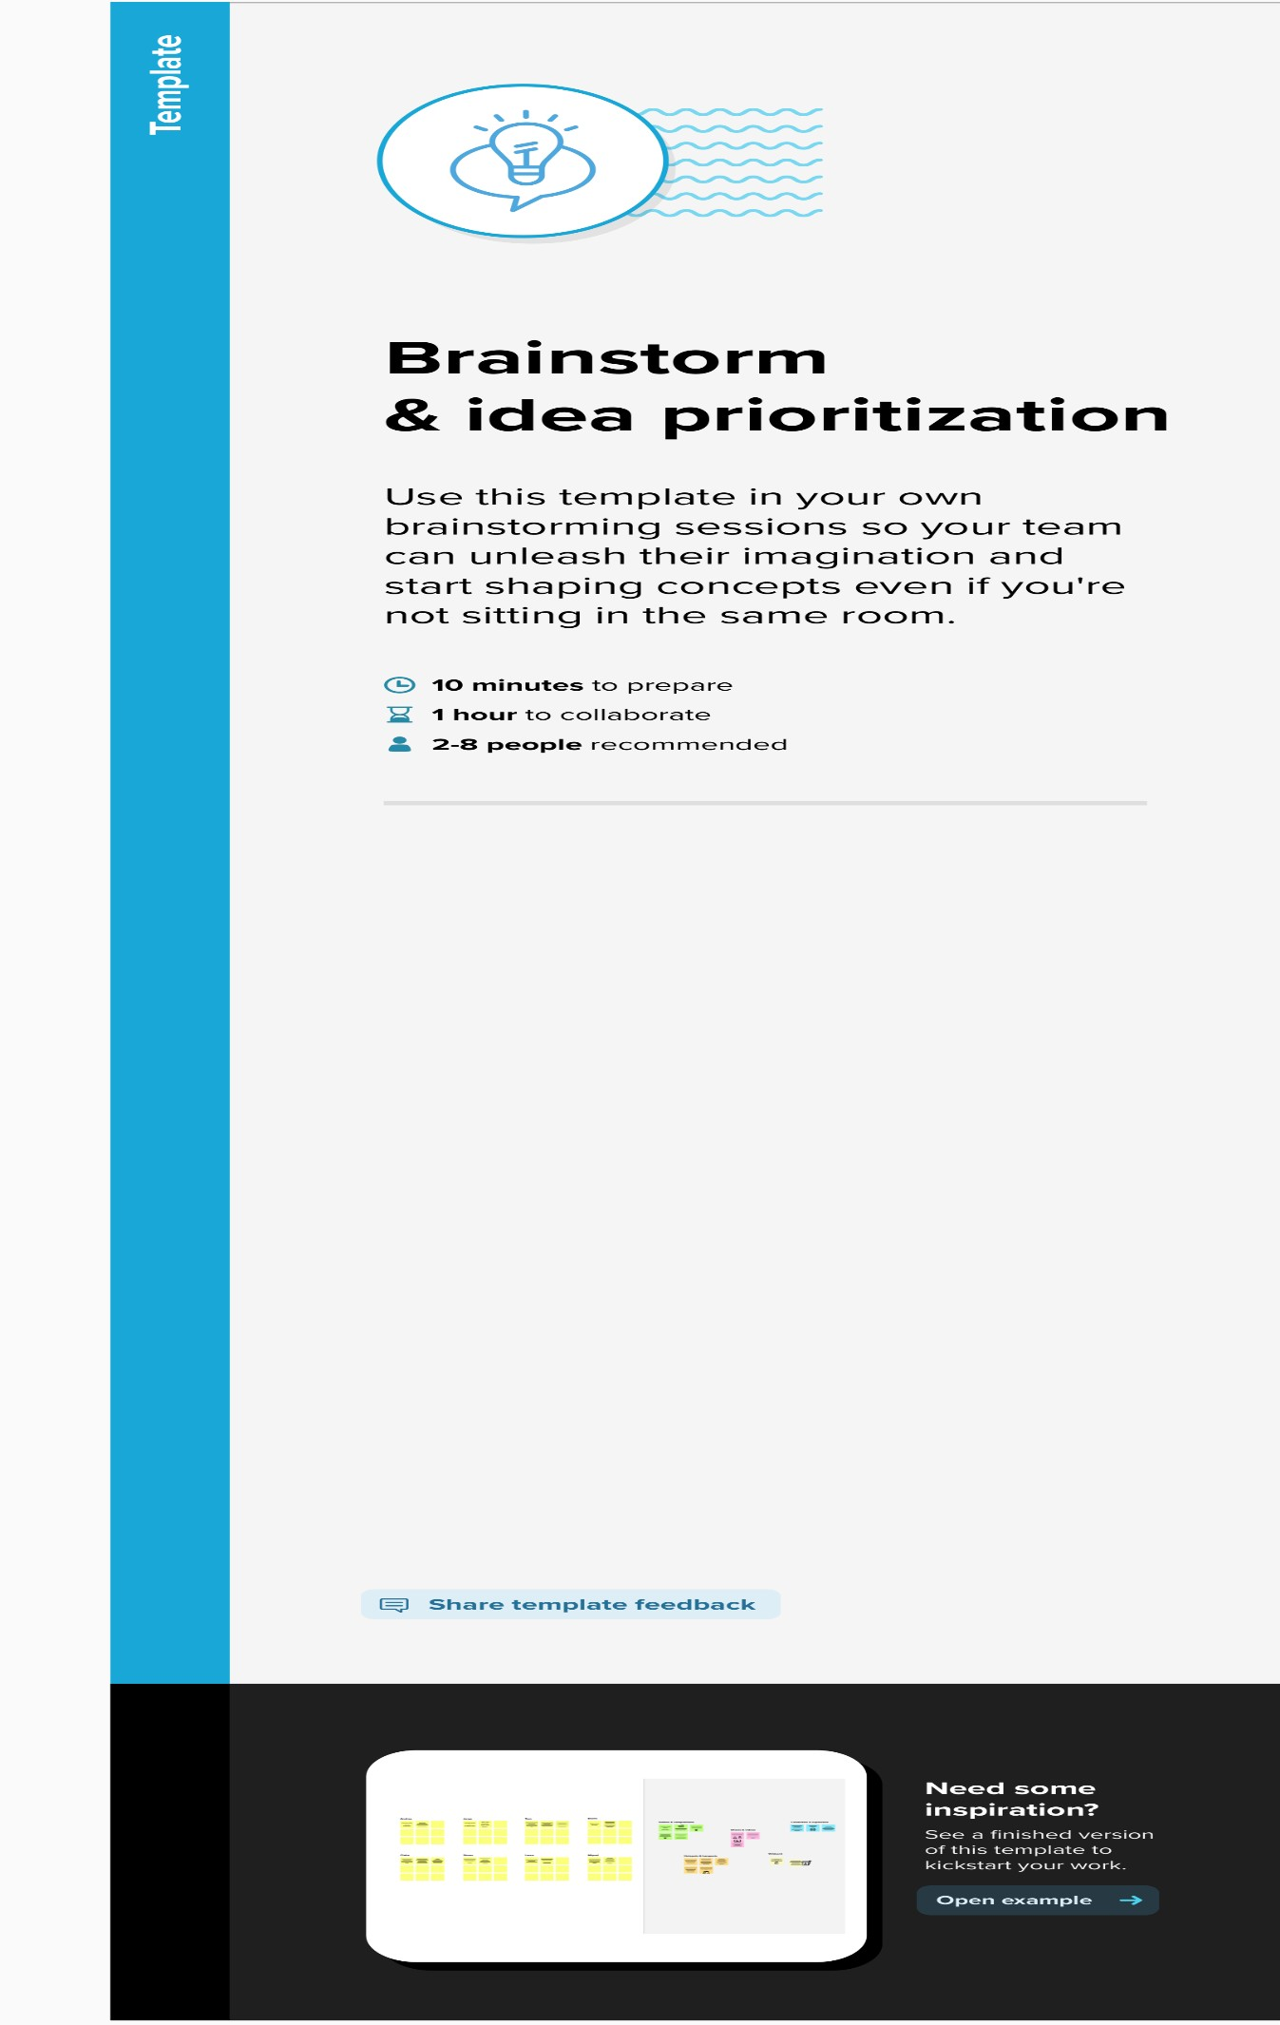

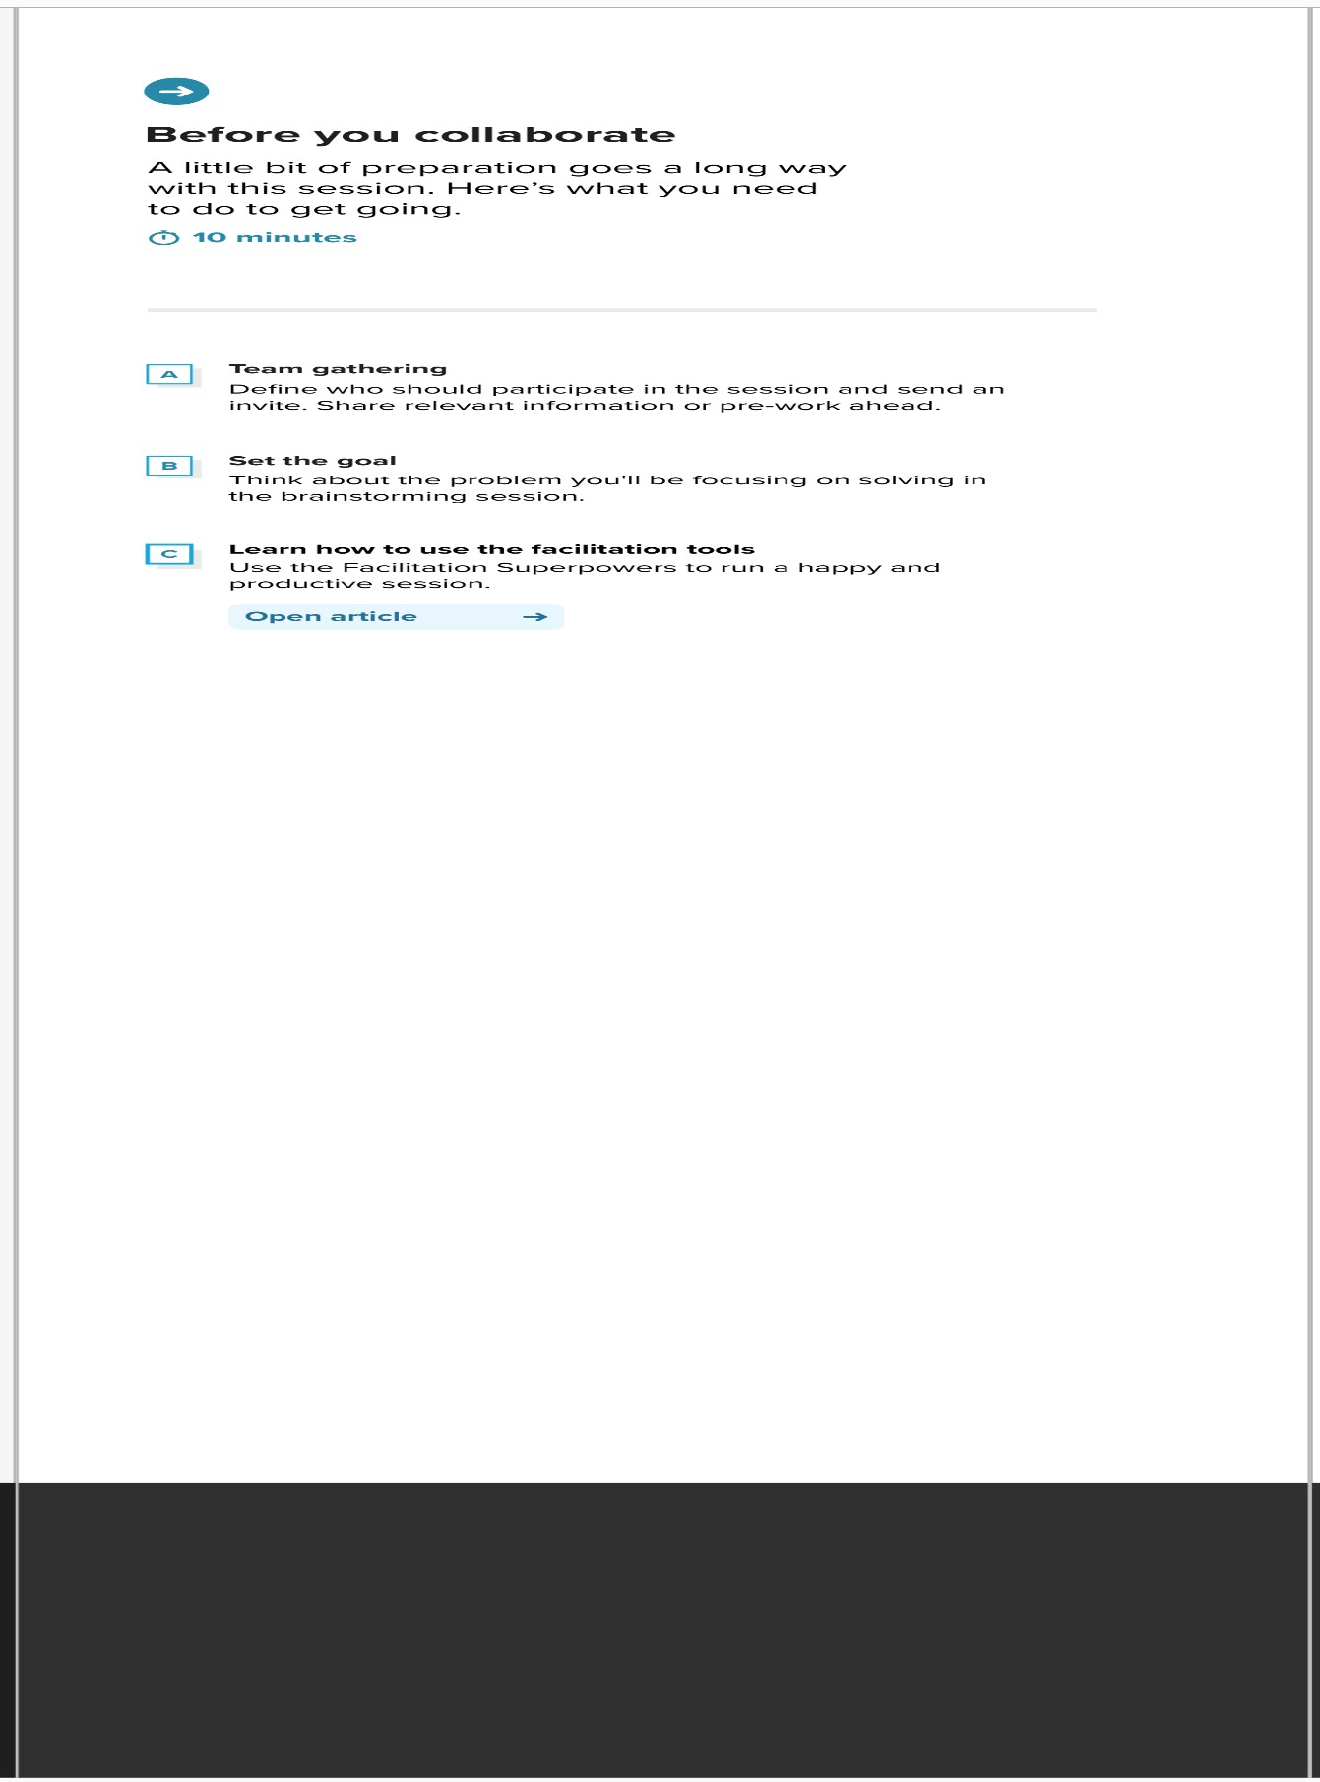

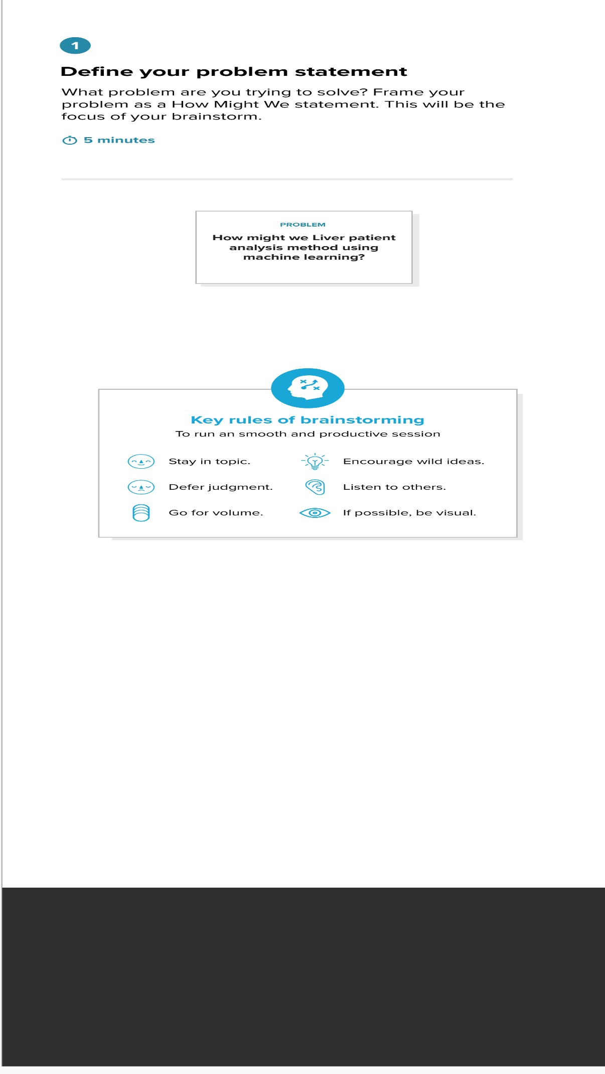

Step:2-Brainstorm, Idea Listing and Grouping

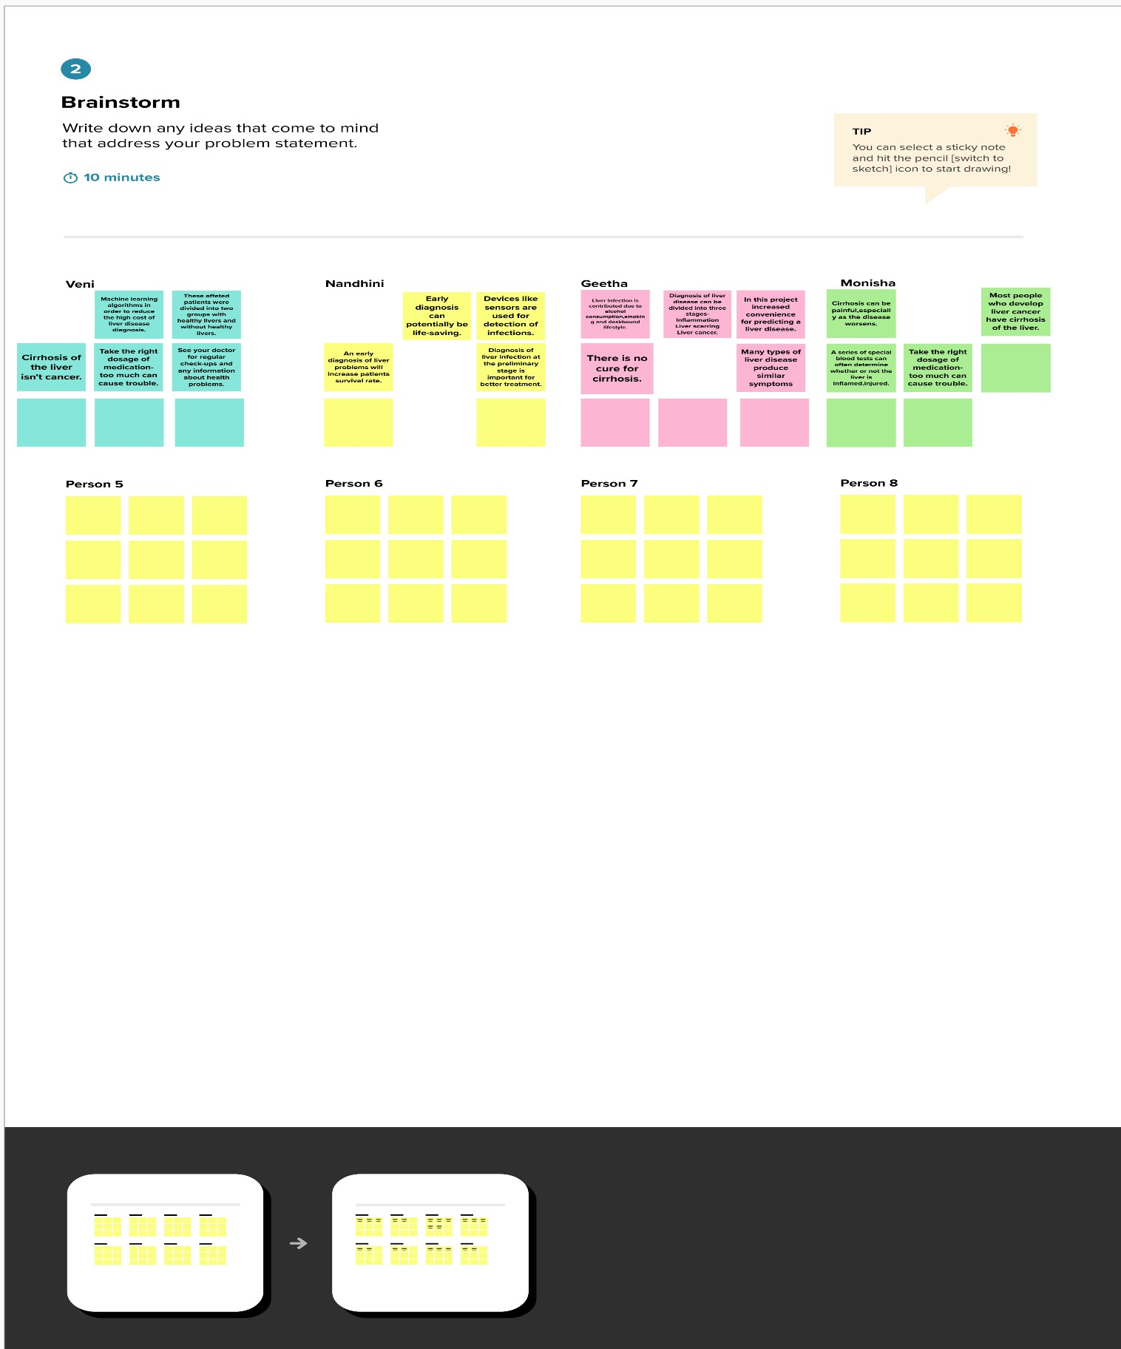

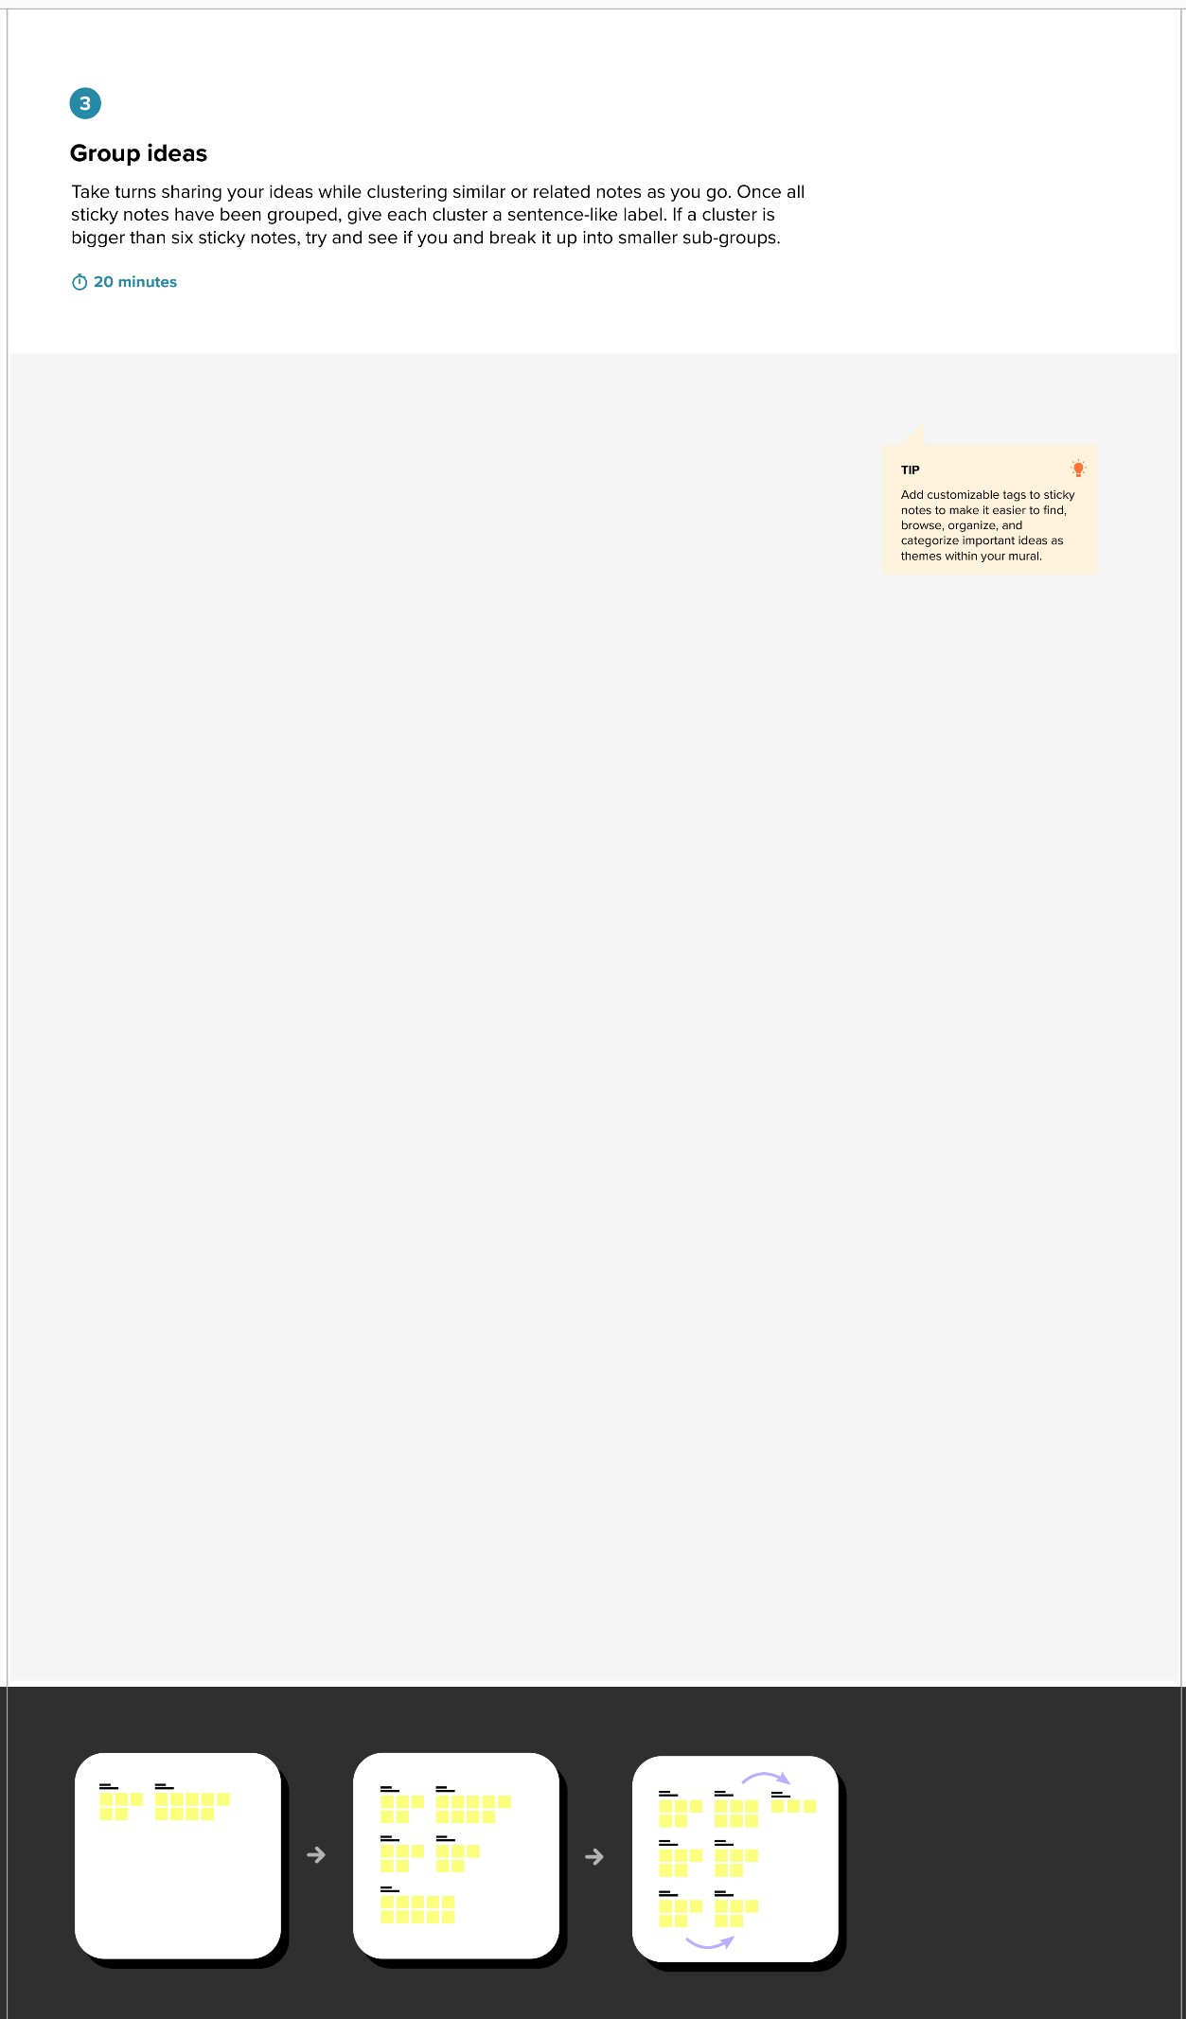

Step:3-Idea Prioritization

